Hotel Bagoeira ***
http://www.bagoeira.com/en/hotel/index.php
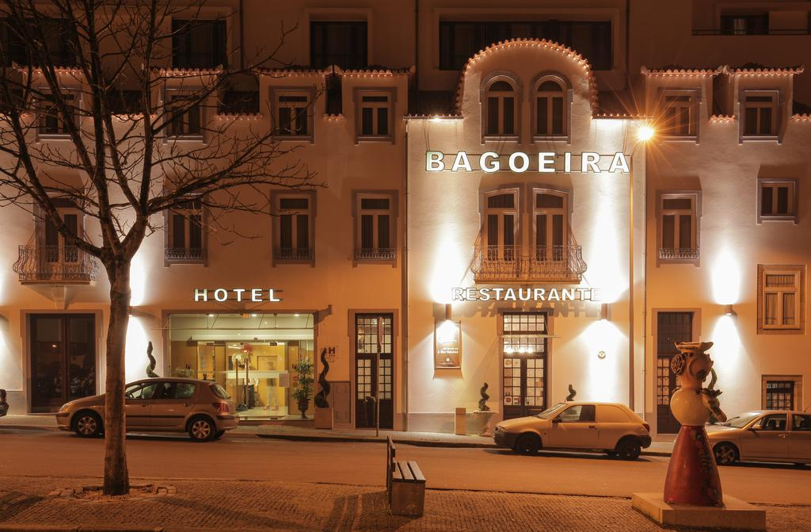

Hotel do Terço ***
http://www.hoteldoterco.com/

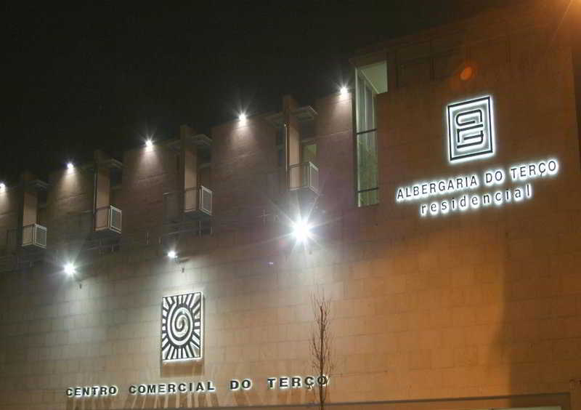

Hotel Dom Nuno
http://www.hoteldnuno.com/

